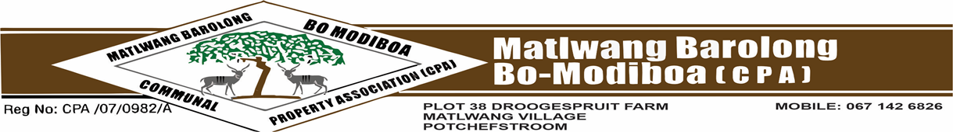
OFFICE OF THE SECRETARIAT AND COMMUNICATIONS
Enquiry: Mr. MN Kganticoe Cell no: 067 6941 926
email: mokgethikganticoe5@gmail.com
: Ms. JM Seboko Cell no: 076 6469 754
email: jeannyseb6@gmail.com

VERIFICATION FORM FOR MEMBERSHIP
This form must be accompanied by any or all the following supporting documents:
- Certified ID copies of applicant.
- Family tree
- Death certificate of ODI (if applicable)
- Marriage certificate (if applicable)
- Affidavit that will be provided.
PERSONAL DETAILS

Initials: ____________ Title: _________________
Surname: ____________________________
Full Names: ____________________________________
ID Numbers: ____________________________ Date of Birth_______________
Home Address: __________________________________________________
Contact Details: (H)__________________ (W) ___________________
(Cell) _________________
Email: ______________________________
Gender: Male Female (tick were appropriate)

(tick were appropriate)
Marital Status: Married Divorced Separated Widower Single

Full Names of ODI: __________________________
Relationship of the applicant to the ODI: _________________________
Name of Dependents of the applicant: ________________________________
_____________________________________________
______________________________________________
______________________________________________
Name of Kgoro: _____________________
Full Names & Surname of Kgoro Rep: ______________________
Contact No: __________________________
Signature of Kgoro Rep: __________________________
AFFIRMATION/DECLARATION

I____________________________________ solemnly declare that I will abide by the aims, objectives, policies and Constitution of Barolong boo Modiboa (Ba Matlwang) CPA, Section 2 of the Restitution act, and I also declare that the above given information including attachments are true and correct to the best of my knowledge. I am also aware and agree that should the committee find that the information provided above is/was false and/or fraudulent, my application will be suspended and/or be terminated.

Applicant’s signature: Date:
____________________________ ______________________
Witness’s signature: Date:
____________________________ ______________________

FOR OFFICE USE ONLY

Date Received: _______________________
Received by: __________________________
Outcome of the Application: Approved Declined Pending

Reason: (if declined/pending) ________________________________________________________
Full Names & Surname of Verification Rep: _____________________________
Contact No: __________________________
Verification Rep signature: Date:

____________________________ ______________________

Signature: Chairperson: KV Ratikoane
Chairperson’s stamp

Secretary: MN Kganticoe.
Signature: ___________________________ Date________________

VERIFICATION AFFIDAVIT

I ______________________states under oath/affirm in (language)__________
(1)
I am an adult/minor male/female with ID no: __________________ age______
residing at______________________________ with telephone number
_____________ and working at_______________________________________
Occupation________________________ cell no_______________
home language____________
(2)
I solemnly declare that I will abide by the aims, objectives, policies and Constitution of Barolong boo Modiboa (Ba Matlwang) CPA, Section 2 of the Restitution act, and I also declare that the above given information including attachments are true and correct to the best of my knowledge. I am also aware and agree that should the committee find that the information provided above is/was false and/or fraudulent, my application will be suspended and/or be terminated.

That’s all I want to declare/affirm.

Witness: _______________________
Witness: _______________________
Date: ________________
Time: ________________
Place: ________________

________________________
Signature/thumb print/mark.

